**System Operational Requirements**

**By:**

**Net 1 Bier**

**Randolph Bock 25905570**

**FJ Fourie 26047799**

Supervisor: Prof J. Holm

Potchefstroom

2017

**Contents**

1 System Operational Requirements 1

1.1 Functional Analysis – Operational Level Architecture and Behaviour 1

1.2 Physical Requirements (Form): 4

1.3 Interface requirements(Fit): 4

1.4 Additional Requirements: 5

Bibliography 7

**List of Figures:**

Figure 1: System Operational Architecture 2

Figure 2: System Operational Flow 3

**List of abbreviations:**

* FSM – Finite State Machine
* UDP – User Datagram Protocol
* OS – Operating System
* SoC – System on Chip
* SBC – Single Board Computer.
* DCS – Door Contact Switch

# 1 System Operational Requirements

## 1.1 Functional Analysis – Operational Level Architecture and Behaviour

1.1.1 System Operational Architecture:

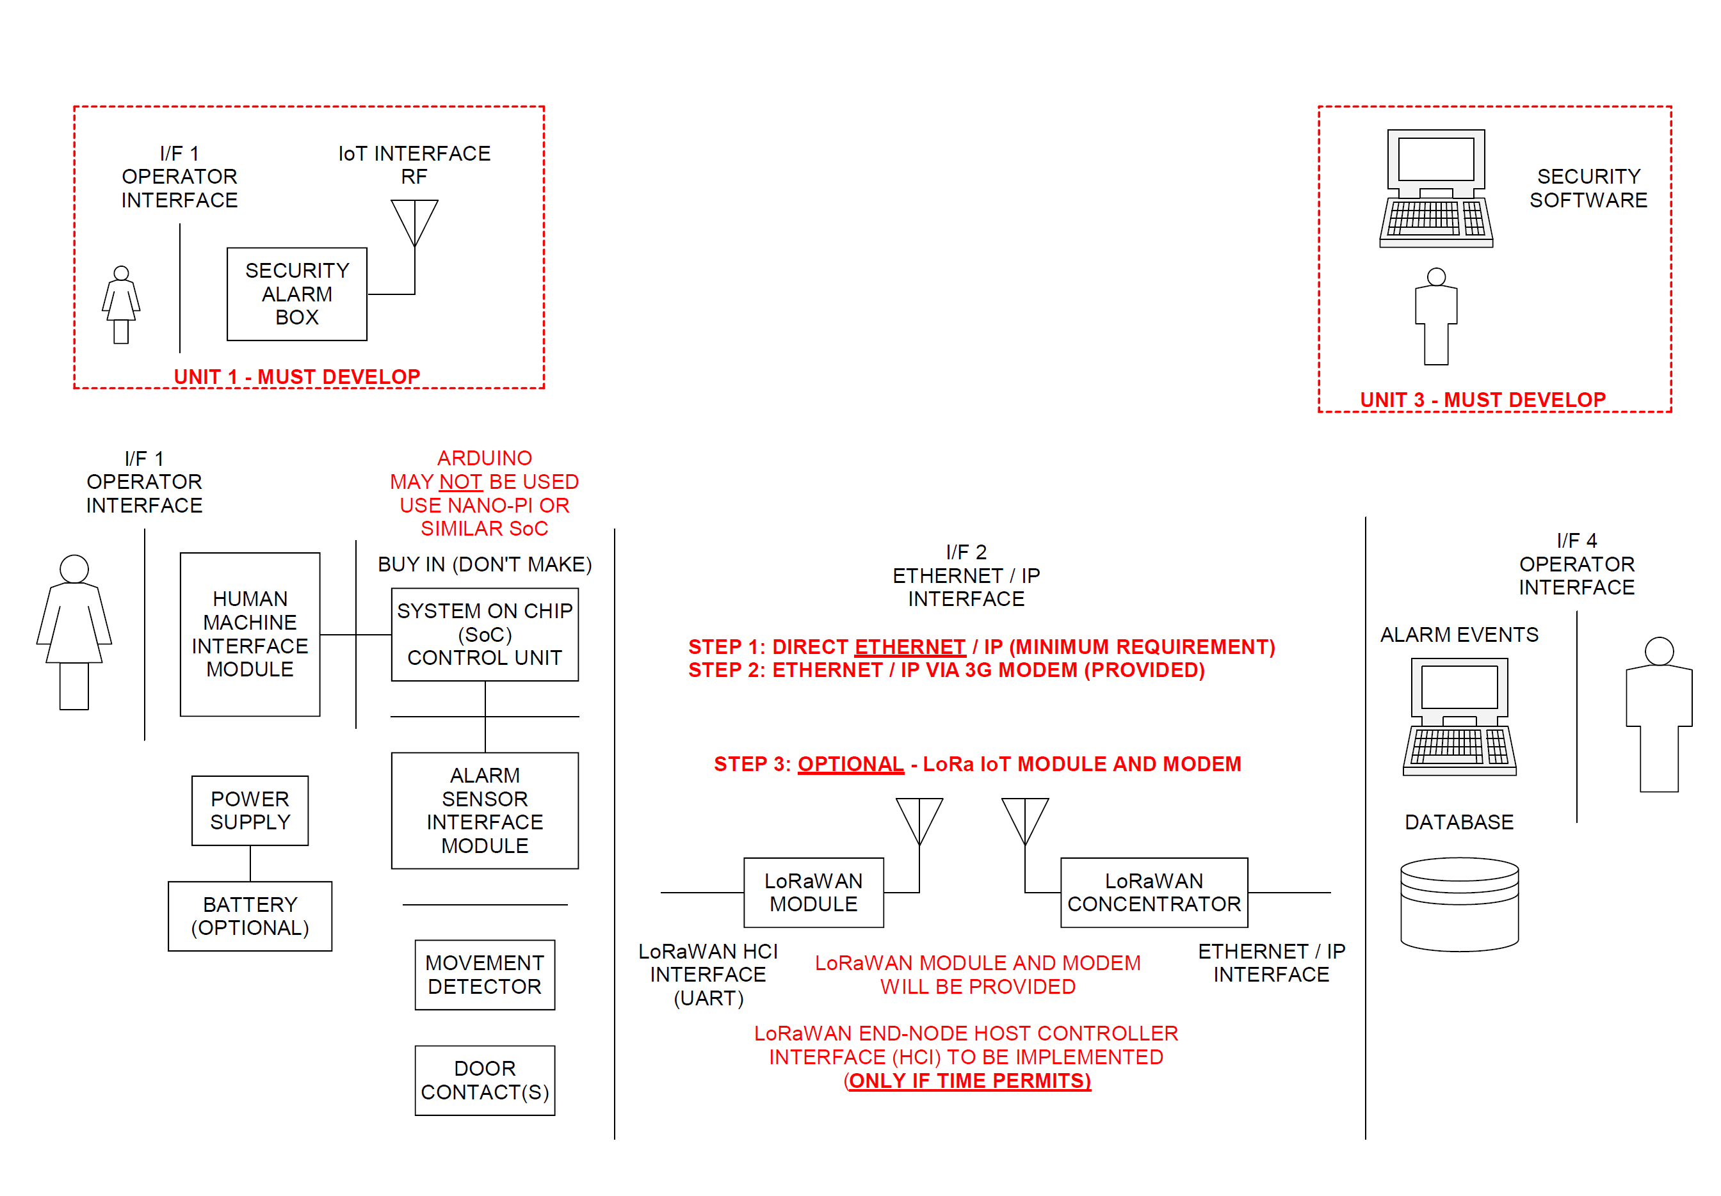

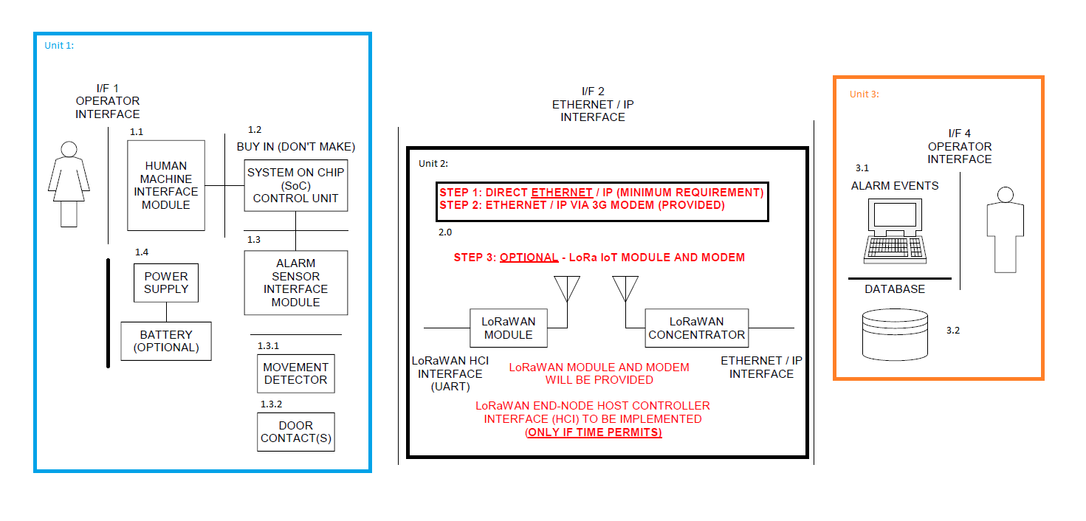

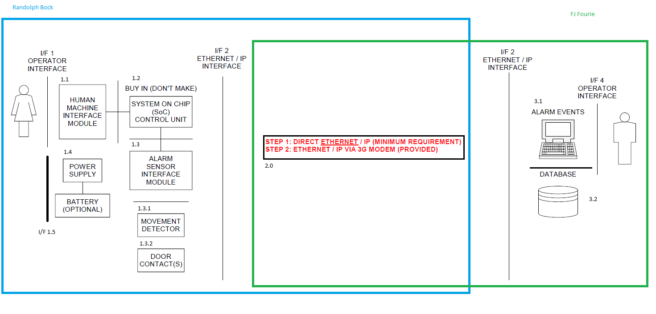

Figure : System Operational Architecture

1.1.2 System Operational Flow:

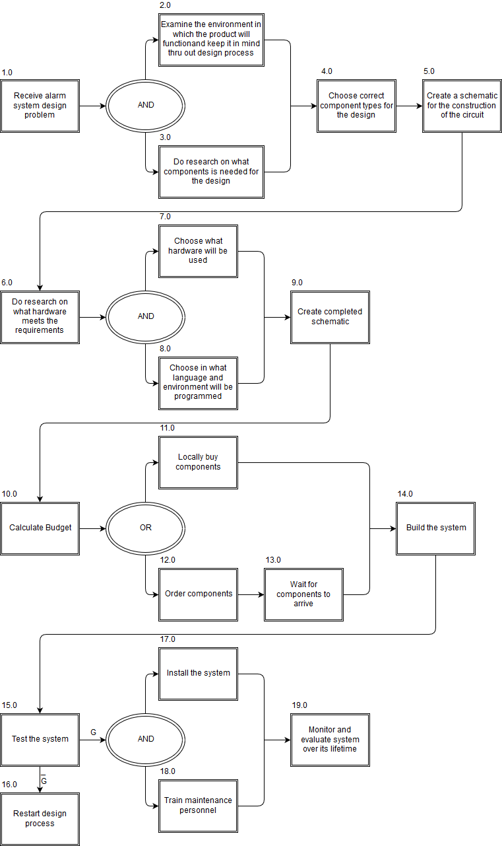

Figure : System Operational Flow

## 1.2 Physical Requirements (Form):

* The alarm panel as well as any sensors of the system must be IP54 rated.
* The alarm panel must be wall mountable
  + The Design must not exceed 0.5Kg as to be easily wall mountable
* Unit should not protrude at strange angles that will cause harm to people passing by. All edges must be smooth to the touch, with no sharp object on the unit to cut/hurt.
* Functional shape that will fit into any home without inconvenience
* Size of unit must not be to large
  + 1m x 1m x 0,5m size constraint
* The alarm panel must allow for wires to enter the panel without damaging the wires. A rubber grommet is used to protect wires extruding from the unit.
* The placement on the wall cannot be too high as it will make it difficult for users to access the panels 1.6 meter from floor level is recommended, this can be varied for specific user use.
* The placement cannot be to low either as it may become a risk for small children, placement must be more than 1 meter from floor level
* The placement should not be over pre-existing water pipes or wiring in the wall

## 1.3 Interface requirements(Fit):

* The interface between the end user and the alarm will be both audio and visual, and be easily understandable (I/F 1.1)
* All items on the functional architecture must be developed, apart from PIR and other sensors (I/F 1.4)
* The single board computer (SBC) will be a Raspberry Pi
* An output will be provided to the Power Block to show that motion has been detected on an “outdoor sensor”
* The input power to the Alarm Panel will be provided from the Power Block and will be 12V at a maximum of 6W (I/F 1.5)
* The interface between the incoming power and the internal power supply of the system will be a two-wire interface, positive and negative wire, to be connected to the system with screw in wire terminals. (I/F 1.5)
* The Alarm Panel will provide its own internal voltages for the SBC and other components (Unit 1.4)
* The network communication between the Alarm panel and the backend-server is to be done with a direct ethernet connection or a WIFI connection (I/F 2)
* The database server will initially be hosted on a laptop or PC.

## 1.4 Additional Requirements:

1.4.1 Environmental Requirements:

* The alarm panel as well as any sensors of the system must be IP54 rated
* Dust proof rating of 5, Limited protection against dust ingress. (no harmful deposit) [1]
* Water resistant rating of 4, Protected against splash water from any direction [1] .
* Temperature requirement of -5°C to 40°C
* Will be made reasonably tamper proof. Wires are tied down internally to prevent the destruction of internal component when the extruded wires are being tampered with.
* The Alarm panel is to be serviceable with the use of a key to open the unit. Key will only be available to trained technicians.
* Will be made from strong material to endure some wear a metal chassis is to be used for the alarm panel
* The system must be protected against Electro Static Discharges, ESD.

1.4.2 Safety requirements

* The system will be grounded to ensure no electrical shocks can occur to an end user
* No open wires
* Not accessible to children
* Closed box so that people who do not understand the device cannot tamper with it
* Reasonably tamper proof

1.43 Legislative Requirements (SAIDSA bylaw 25) [2]

* Control equipment [2]
  + Control panel installed min of 1.5 m form ceiling
  + Digital keypads must be of the data transfer technology type
  + Disarming delay no more than 30 seconds
* Signalling equipment [2]
  + Signalling equipment will be positioned within the protected area
  + Not placed where telephone lines are vulnerable
* Maintenance [2]
  + Inspect and test each detection device back to control panel
  + Inspecting alarm panel and transmitter
  + Inspect cables for visible damage

1.4.4 Usability Requirements:

* System must be easily operated with minimal training required to operate the system
* Compensation for mounting will be made for the control box

# Bibliography

|  |  |
| --- | --- |
| [1] | “IP Ratings (Ingress Protection),” MPL, [Online]. Available: https://www.mpl.ch/info/IPratings.html. [Accessed 15 11 2017]. |
| [2] | “Bylaw 5 - Saidsa,” SAIDSA, September 2015. [Online]. Available: https://www.google.com/url?sa=t&rct=j&q=&esrc=s&source=web&cd=3&ved=0ahUKEwi5p8OwrcDXAhUhCsAKHYDIDuoQFggxMAI&url=http%3A%2F%2Fwww.saidsa.co.za%2FBylaw%25205.pdf&usg=AOvVaw0TZs7890v9HAXQL9Pm9Ln5. [Accessed 16 September 2017]. |